Linux with Windows 10 UI
Sounds weird? But is possible!
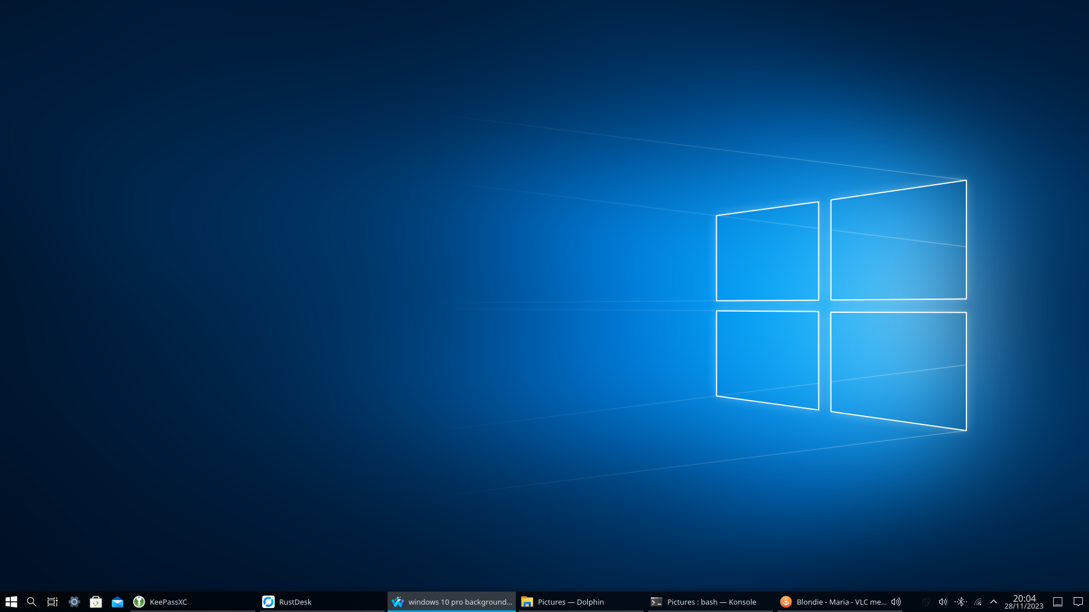
To make Linux look like Windows 10 some steps are required, this tutorial shows how to do this.
Firstly you need a KDE/Plasma desktop environment, therefore you can either use the official Ubuntu-derivate Kubuntu or any Linux distribution with the KDE/Plasma-Desktop environment installed.
This tutorial was tested against Ubuntu 22.04/23.10 with KDE/Plasma (Kubuntu) and Debian 12/13 with KDE/Plasma.

Required themes
To start, open the settings app an go to Global Theme. Click on Get New Global Themes… After that search for Win10Sur-dark Global Theme store.kde.org - Win10Sur-dark, click Install and then Use. Now continue with this procedure for the following theme settings:
Setting | required Theme | URL
Global Theme | Win10Sur-dark | store.kde.org - Win10Sur-dark
Plasma Style | We10XOS-dark-custom | store.kde.org - We10XOS-dark-custom
Window Decoration | Win10OS Aurorae-dark | store.kde.org - Win10OS Aurorae-dark, if it's not downloadable from store.kde.org, use clone the GitHub repository and install it manually github.com
Icons | KWinDE | store.kde.org - KWinDE
Cursors | Win10OS-cursors | store.kde.org - Win10OS-cursors
Errors can occur, for now you can ignore them, if any persistent errors are present try rebooting and reinstalling.
To remove this annoying three dots:
Go to Window Decorations and Titlebar Buttons. Then drag the pin down and apply your changes. Now your titlebar looks clean like in Windows 10.
Sometimes the install process of themes fails, in this case try rebooting your whole system. If this doesn't fixes the problem, completely uninstall the affected theme pack, apply the default theme and rebegin the installation process.

Login-Screen
Unfortunately there is no fancy theme for Plasma's lock screen, but switching to Win10Sur-dark under Login Screen (SDDM) can make the lock screen look better than it's looks originally.

Windows 10 like startmenu, search and notification button
There is a cool Windows 10-like start menu called Tiled Menu for Plasma: store.kde.org - Tiled Menu. To install it, right-click the taskbar and select Add widgets, then click Get New Widgets and search for Tiled Menu. Install the widget, reopen the widget-adding panel and drag the widget to the desired position.
Search and notification buttons are also a plugins for Plasma's taskbar, search either for search or notification and drag the widget to any position on the taskbar. To prevent a doubled notification icon, disable the notification badge completely for the system tray by right-clicking the system tray and Configure system tray.
To make use of Win+Tab search for the plugin Present Windows Button for Willow, install it and drag also it to the desired position. store.kde.org - Present Windows Button for Willow.
After this steps the taskbar can look like this:

Custom icons
Therefore that some icons are looking a bit weird, here are some icons you can use to make them look better:
Task-View-Icon:
Feel free to use this icon!
Due to copyright reasons please download a Windows 10-Icon for the start menu for your self.
To change the icon of an app, open the menu, search for the app, right-click it, select Edit application and change the icon in the windows that just appeared.

Optional Settings
If you wish to have a different taskbar you can change the default Icons-only Task Manager to Task Manager by right-clicking the taskbar and then Show alternatives:
Icons-only Task Manager:
Task Manager:

Image Source Windows Background (28.11.23)

