Backup Solutions (GUI)
This site requires a rework. We're working on it! Although we leave it online for documentation purposes.

Pika
Simple graphical backup solution based on vorta (Remote or local backup):
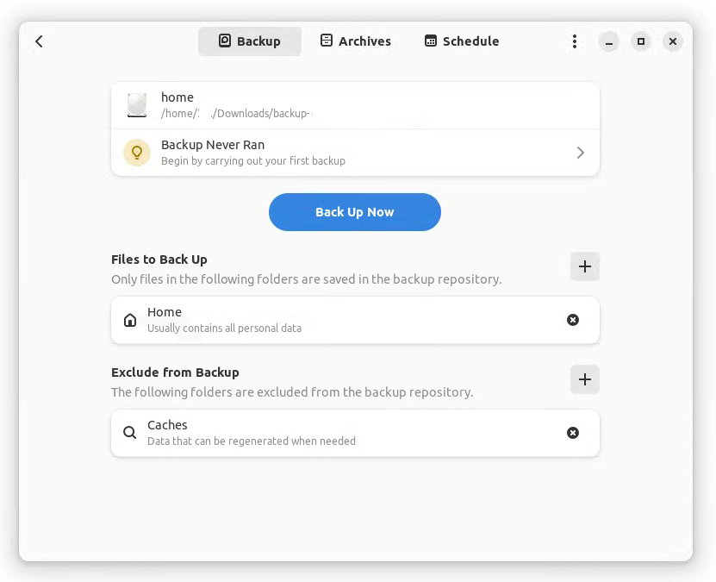
Works on:
- Linux (GNOME)
Installation as flatpak:
Follow this guide to setup flathub on your distribution: flathub.org/setup
flatpak install flathub org.gnome.World.PikaBackup
Source code: github.com/pika-backup/pika-backup

vorta
Another simple graphical backup solution:
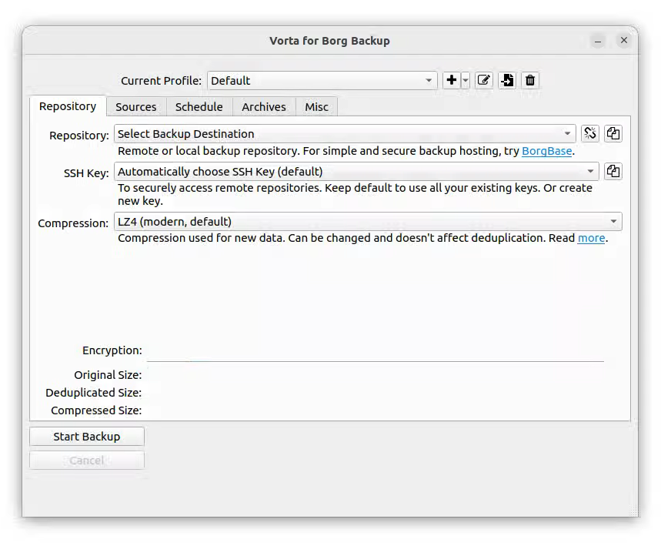
Works on:
- Linux
- macOS
- Windows
APT-Installation:
sudo apt install vorta
Source code: github.com/borgbase/vorta

kbackup
Backup program with an easy-to-use interface:
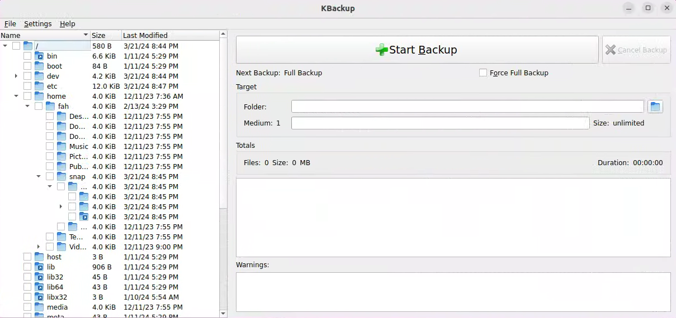
Works on:
- Linux
Installation via SNAP:
snap install kbackup
Source code: invent.kde.org/utilities/kbackup

Freefilesync
URL: freefilesync.org
Works on:
- Linux
- macOS
- Windows

Sourced from youtube.com - Novaspirittech - 4 Linux Backup Utilities (last access: 21.03.2024)

