Waterfox on Linux (Install/Settings)

Installation from flatpak
→ flathub.org/en/apps/net.waterfox.waterfox
flatpak install flathub net.waterfox.waterfox

Waterfox Installation from Repository (Debian, Fedora, CentOS)
Although there are no official Debian repositories for Waterfox, it can be installed from a repsoitory with APT.
Repository: opensuse.org
Therefore use this commands:
sudo apt update && sudo apt upgrade -y
sudo apt install software-properties-common apt-transport-https curl -y
Quick install:
Just run the following command to get the repository key and install it:
curl -fsSL https://download.opensuse.org/repositories/home:hawkeye116477:waterfox/xUbuntu_24.04/Release.key | sudo gpg --dearmor | sudo tee /etc/apt/trusted.gpg.d/home_hawkeye116477_waterfox.gpg > /dev/null
Then add the repository to the sources lists:
echo 'deb http://download.opensuse.org/repositories/home:/hawkeye116477:/waterfox/xUbuntu_24.04/ /' | sudo tee /etc/apt/sources.list.d/home:hawkeye116477:waterfox.list

Longer, bit outdated way:
wget https://download.opensuse.org/repositories/home:hawkeye116477:waterfox/Debian_11/Release.key
Replace Debian_11 with your distribution, e.g. Debian_12. Therefore have a look at download.opensuse.org/repositories
gpg --dearmor Release.key && cat Release.key.gpg | sudo tee /etc/apt/trusted.gpg.d/home_hawkeye116477_waterfox.gpg > /dev/null
rm Release.key*
echo 'deb http://download.opensuse.org/repositories/home:/hawkeye116477:/waterfox/Debian_11/ /' | sudo tee /etc/apt/sources.list.d/home:hawkeye116477:waterfox.list
sudo apt update
sudo apt install fonts-lyx ffmpeg -y waterfox-g-kde
Sourced from linuxcapable.com
Ubuntu specific instructions: Waterfox on Ubuntu or Zorin OS

Waterfox Installation via flathub
Simply run:
flatpak install flathub net.waterfox.waterfox
Disclaimer: packages might be a bit outdated when sourcing from flathub!

Waterfox system's titlebar on Plasma
When installing Waterfox on a KDE/Plasma environment, it could be that Waterfox's default setting is to use a custom title bar like this:
In some configurations this can look very ugly like above. But it's possible to change this, therefore navigate to More tools > Customize toolbar and tick the check in the lower left corner that says Title Bar: 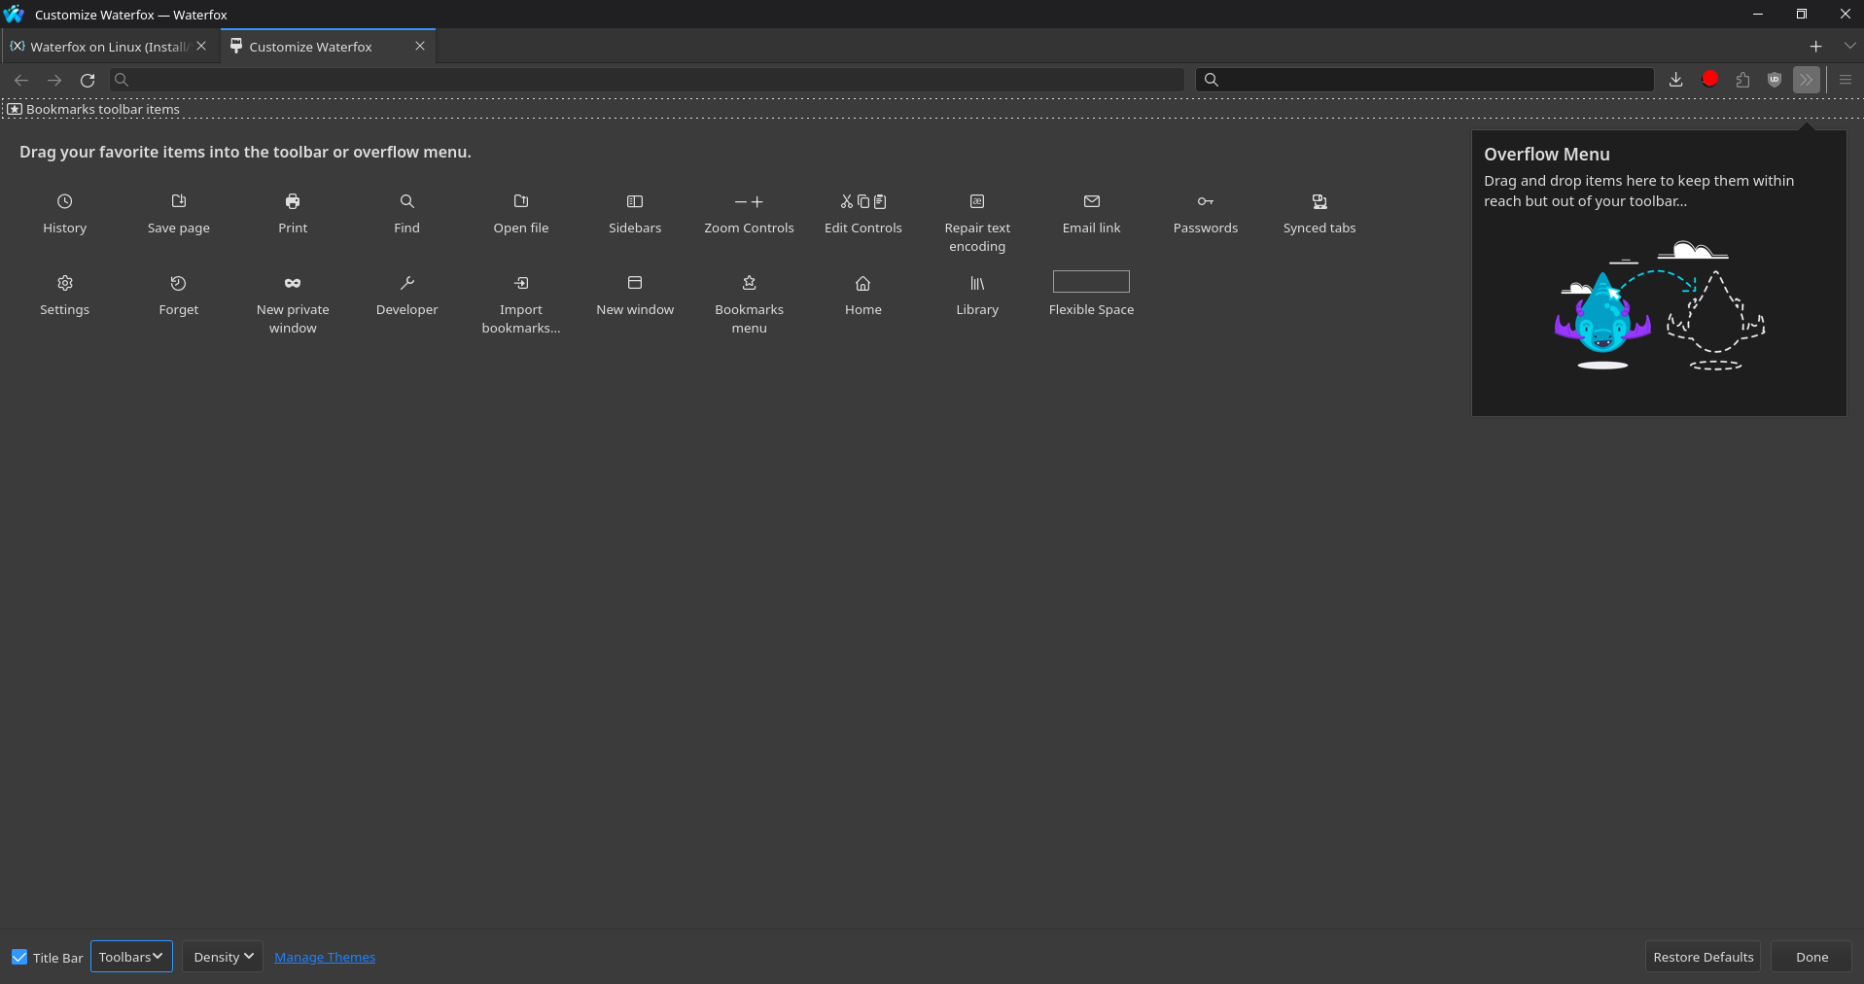
Finally your Waterfox should look like this:
Sourced from askvg.de - Firefox Settings

Fix missing fonts
It might be, that some webpages will be displayed in Times New Roman font, to fix that install the missing fonts by just installing the packages ttf-mscorefonts-installer and fonts-lyx:
sudo apt install ttf-mscorefonts-installer fonts-lyx ffmpeg
The package ffmpeg will additionally make video and audio output possible.

