Check Raid-Controller state with Observium (LSI/Adaptec)
Both methods have been tested on Debian.
To monitor a RAID-Controller (not the RAID-State) with Observium the Observium-Agent can be used:
- Firstly install Observium's Agent by using this script: github.com/Zyzonix/attic - observium-agent-quick-install.sh
- Then verify that the correct software for the RAID-Controller in use is installed. LSI: MegaCLI64 and Adaptec arcconf is required. Verify a correct working of the software, otherwise the agent's module hdarray will not work.
- Enable hdarray:
ln -s /usr/lib/observium_agent/scripts-availabe/hdarray /usr/lib/observium_agent/scripts-availabe/.
- Restart the socket:
systemctl restart observium_agent.socket
- Finally add an Alert-Checker for Status with the following settings: Conditions: status_event noteuqals ok and associate it with Status entPhysicalClass equals controller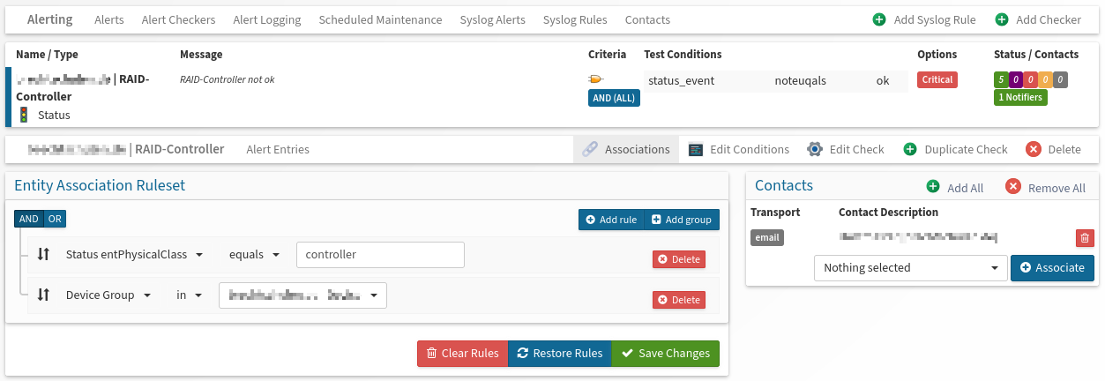

Other Method to monitor the RAID-state (insecure/outdated)
To use this method the enterprise version of Observium is required!
Structure of this method: Observium uses the check_by_ssh plugin from Nagios to connect to the remote machine via SSH. A special user with limited access will then execute the check_raid-Plugin (also from Nagios) on the remote machine and will then send back the output to Observium. An alert checker can then check the RAID-state.
Setup:
- Firstly install monitoring-plugins-contrib on the remote machine and monitoring-plugins-basics on Observium.
- Then add a user called observium on the remote machine and add him to the group ssh:
sudo usermod -aG ssh observium
- Edit the /etc/sudoers file and allow observium to execute check_raid, therefore add the following lines:
# Add permission for knecht (used by Observium) to execute check_raid
observium ALL= NOPASSWD: /usr/lib/nagios/plugins/check_raid
- Now allow password-less authentication by copying the SSH-keys from the observium machine to the remote machine:
ssh-copy-id -i .ssh/id_rsa.pub observium@<remote-ip>
- By default the check_by_ssh plugin is disabled for Observium. Enable it by adding the following lines to /opt/observium/includes/definitions/entities/probes.inc.php:
// Custom extension for remote checks
$probe = 'check_by_ssh';
$config['probes'][$probe]['enable'] = 1;
$config['probes'][$probe]['descr'] = 'Execute checks remotely via SSH';
// End of custom code
- Finally restart apache2
- Now add a probe in Observium's webinterface with the following values:
Config-Option | Value
Device | Remote-Device
Probe Type | check_by_ssh
Description | RAID | <hostname>
Extra arguments
  -H <hostname> -l observium -C '/usr/bin/sudo /usr/lib/nagios/plugins/check_raid'
Check /opt/observium/includes/definitions/entities/probes.inc.php after each update to verify that check_by_ssh is still enabled!

